1. COMMAND OVERVIEW

a. UKMTO has received a number of reports of suspicious vessels during the current week. No attacks transpired. It is very important that any suspicious vessels are reported to UKMTO by telephone. Military units can then be alerted.

2. EXECUTIVE SUMMARY

a. Reported piracy related incidents (a visual representation can be found at Annex A when there are incidents to report):

- Attacked

No incidents to report.

(2) Boarded

No incidents to report.

(3) Hijacked

No incidents to report.

b. Vessels/crew still under pirate control (details can be found at Annex B):

1 | Merchant vessel |  |  | 16 | Personnel
6 | Fishing vessels & Dhows |  |  | 46 approx | Personnel
 | Other crew still held |  |  | 17 | Personnel
 |  |  |  | 79 approx | Total Personnel

c. 39 ships were briefed in Jebel Ali (details can be found at Annex C). Of the ships briefed, 28 ships confirmed that they were carrying or had carried Armed Guards recently.

d. UKMTO data can be found at Annex D.

e. Alternative sources of information can be found at Annex E

3. LIAISON AND VISITS

a. Visits and Liaison

19 Mar OIC - SHADE
Capt AJP White RN – COS UKMCC
Capt S Riordan and Mr D Sango – Shell
20 Mar Mr T Gibson and Lt Cdr I Ritchie RN – Navy Command
21 Mar MIEVOM
22 Mar Mr John Brown – Law of the Sea Consultant UKHO

b. Future Events

S N Goodes RD
Lt Cdr RN

OIC UKMTO
NP 1023
BFPO 490

Tel: +971 50 552 3215
Email: ukmto@eim.ae

ANNEXES:

- Reported Piracy Related Incidents
- List of Vessels Still Under Pirate Control
- List of Ships Briefed
- UKMTO Data
- Alternative sources of information
Annex A to
UKMTO Weekly Report
Dated 23 March 13

REPORTED PIRACY RELATED INCIDENTS

No incidents to report

Back to Executive Summary
Annex B to
UKMTO Weekly Report
Dated 23 March 13

LIST OF VESSELS STILL UNDER PIRATE CONTROL

1 Merchant Vessel in Pirate Captivity

No | Name | IMO | Flag | Type | Crew | Date Taken
 | ICEBERG I | 7429102 | Panama | RoRo / Cargo |  | Reported as Aground
1 | ALBEDO | 9041162 | Malaysia | Container | 16 in total Indian, Bangladeshi  & Sri Lankan | 26/11/10

6 Dhows and Fishing Vessels Confirmed in Pirate Captivity

No | Name | IMO | Flag | Type | Crew | Date Taken
1 | AL NASSER |  | Yemen | Dhow | N/K | 28/10/10
2 | ABDI KHAN |  | Yemen | Fishing Vessel | N/K | 16/04/11
3 | GHAZAL HOWLF |  | Yemen | Fishing Vessel | N/K | 02/03/12
4 | NAHAM 3 |  | Taiwan | Fishing Vessel | 29 Unknown | 26/03/12
5 | AL AMOOD |  | Yemen | Dhow | 9 Unknown | 13/04/12
6 | AL FAHAD |  | Yemen | Dhow | 7 Yemeni  1 Somali | 14/04/12

Back to Executive Summary

Annex C to
UKMTO Weekly Report
Dated 23 March 13
List of Ships Briefed

39 ships briefed:

Date | Location | Name | Flag
16/03/2013 | Jebel Ali | COSCO THAILAND | Hong Kong
16/03/2013 | Jebel Ali | ANTONIA SCHULTE | Panama
16/03/2013 | Jebel Ali | ELISABETH SCHULTE | IOM
16/03/2013 | Jebel Ali | ALAM BAKTI | Singapore
16/03/2013 | Jebel Ali | OCL EAGLE | Marshall Is
16/03/2013 | Jebel Ali | AL FARAHIDI | Saudi Arabia
16/03/2013 | Jebel Ali | STX EAGLE | Panama
16/03/2013 | Jebel Ali | MORNING MIDAS | UK
17/03/2013 | Jebel Ali | INDEPENDENCE | USA
17/03/2013 | Jebel Ali | SANTA RAFAEIA | Germany
17/03/2013 | Jebel Ali | SAXONIA | Liberia
17/03/2013 | Jebel Ali | APL SPAIN | Singapore
17/03/2013 | Jebel Ali | STADE | Antigua
17/03/2013 | Jebel Ali | KOTA HANDAL | Singapore
18/03/2013 | Jebel Ali | NORA MAERSK | Danish
18/03/2013 | Jebel Ali | VIENNA EXPRESS | Germany
18/03/2013 | Jebel Ali | VENUS TRIUMPH | Panama
18/03/2013 | Jebel Ali | SUNRISE ACE | Liberia
18/03/2013 | Jebel Ali | YM XIAMEN | Liberia
19/03/2013 | Jebel Ali | ATLANTIC SYMPHONY | Hong Kong
19/03/2013 | Jebel Ali | COAL HUNTER | Marshall Is
19/03/2013 | Jebel Ali | HAMMONIA IONIUM | Liberia
19/03/2013 | Jebel Ali | OSPREY ARROW | Bahamas
20/03/2013 | Jebel Ali | FESCO SIMFEROPOL | Marshall Is
20/03/2013 | Jebel Ali | WESTERDIER | Liberia
20/03/2013 | Jebel Ali | FLORA DELMOS | Bahamas
20/03/2013 | Jebel Ali | LILAC VICTORIA | Marshall Is
20/03/2013 | Jebel Ali | GULF VALOUR | Bahamas
20/03/2013 | Jebel Ali | RHEA LEADER | Japan
20/03/2013 | Jebel Ali | ANDINET | Ethiopia
20/03/2013 | Jebel Ali | YM COSMOS | Panama
20/03/2013 | Jebel Ali | KUNIANG | Hong Kong
20/03/2013 | Jebel Ali | JUMME TRADER | Liberia
22/03/2013 | Jebel Ali | FJELLANGER | Norway
22/03/2013 | Jebel Ali | MSC AURORE | Panama
22/03/2013 | Jebel Ali | GRACEFUL LEADER | Bahamas
22/03/2013 | Jebel Ali | MAERSK MISSOURI | USA
22/03/2013 | Jebel Ali | GIBE | Ethiopia
22/03/2013 | Jebel Ali | KOTA ARIF | Singapore
16/03/2013 | Jebel Ali | MORNING MIDAS | Hong Kong
17/03/2013 | Jebel Ali | INDEPENDENCE | Panama
17/03/2013 | Jebel Ali | SANTA RAFAEIA | IOM

Back to Executive Summary

Annex D to
UKMTO Weekly Report
Dated 23 March 13

UKMTO Data:

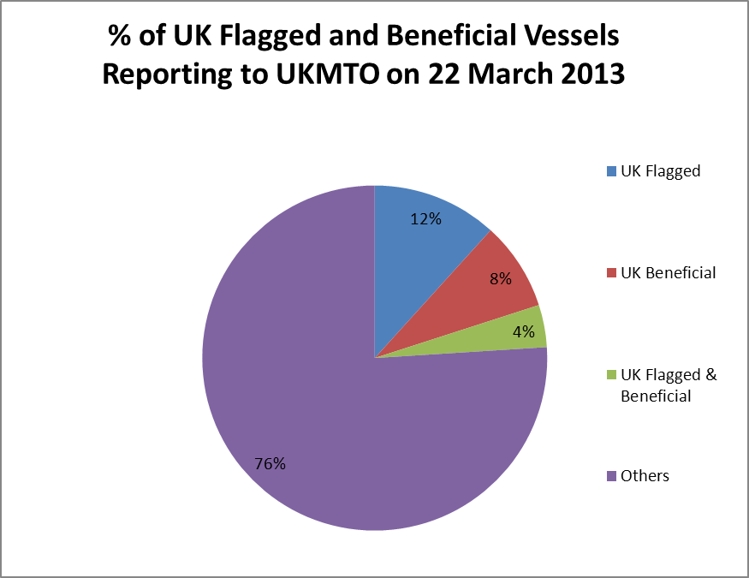

UK Flag and Beneficial vessels reporting to UKMTO | Number for week
Vessels with a UK Flag of Registration | 151
Vessels with a UK Beneficial Owner | 107
Vessels with both UK Flag and Beneficial Owner | 51
Security information | Number for week
Vessels known to be carrying security teams | 632
Of which, vessels declared carrying armed security teams | 584
Other information | Number for week
Total number of ship reports to UKMTO | 13231
Vessels actually reporting to UKMTO | 2204

Back to Executive Summary

Annex E to
UKMTO Weekly Report
Dated 23 March 13

Alternative Sources of Information

Additional and alternative sources of information can be found at the following websites:
- UKMTO – www.royalnavy.mod.uk/ukmto

- NATO Allied Maritime Command - http://www.manw.nato.int/

- NATO Shipping Centre –

  - Alert Details - http://www.shipping.nato.int/Pages/AllAlerts.aspx

  - Weekly Assessment - http://www.shipping.nato.int/operations/OS/Pages/piracyupdate.aspx

  - BMP - http://www.shipping.nato.int/Pages/BMP.aspx

- MSCHOA - http://www.mschoa.org/

- Combined Maritime Forces - http://combinedmaritimeforces.com/

- Maritime Liaison Office (MARLO) - http://www.cusnc.navy.mil/marlo/

- Middle East Navigation Aids Service (MENAS) http://www.menas.org/

Back to Executive Summary

